May 15, 2018

Dear :

Please accept this formal invitation to attend the Association of Nurses in AIDS Care’s Annual Conference as a delegate. The ANAC2018 will be held from November 8-10, 2018 in. The conference hotel is the Hilton Denver City Center in Denver Colorado. Delegates can register for hotel rooms by going to the web at www.nursesinaidscare.org . You must register for the Conference, and registration for the conference can occur over the web at www.nursesinaidscare.org.

During your stay in the United States, you will not be compensated in any way by the Association of Nurses in AIDS Care. You may not be engaged in any employment while in the United States. You are responsible for your own travel expenses, including but not limited to: airfare, other transportation, hotel, meals, travel insurance, etc.

Thank you for your interest in our meeting. Your attendance at this important conference demonstrates your commitment to HIV/AIDS care.

Sincerely,

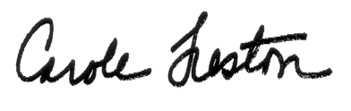
Carole Treston
Executive Director

