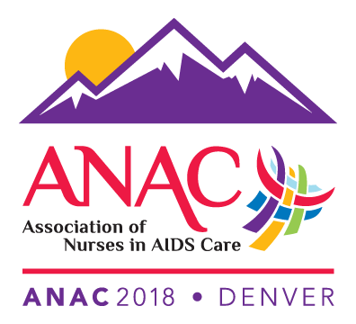

Association of Nurses in AIDS Care
30th Annual Conference
ANAC2018: Denver
November 8-10, 2018 ∙ Hilton Denver City Center Denver, CO

Conference Registration Form

Please complete all information by typing directly in the grey fields. Telephone registrations will not be accepted. Please note that online registration is available at www.nursesinaidscare.org. You may submit this form via fax if paying by credit card. If paying by check, please print and mail to ANAC at the address listed below.

Full Name:
Address:
City: State: Zip: Country:
Phone: Email Address: Fax:
ANAC ID# (If applicable):

Emergency Contact Information
Name of person to contact in case of an emergency:
Relationship to you:
Phone number of emergency contact:

Conference Fees

Reduced Registration 5-1-2018 Thru 7-15-2018

 | Full Registration | Amount Enclosed
Active/Affiliate Member | $445 | $
ANAC Discounted Active Member (student, Disabled, Retired) | $275 | $
Nonmember | $545 | $
Daily Rate | $175 | $

Awards Dinner/Ceremony
Saturday, November 10th, 7:00 – 9:00 pm, $30.00 fee +$30.00

Guest Registration
Includes entry to Gala, Exhibit hall, Awards Dinner +$200.00
Name of Guest:

Total amount enclosed/to be charged (payment must be in USD) $__________

Method of Payment: Check or money order
Visa
Mastercard
Discover
American Express

Credit Card Authorization

Name on Card: Card Number: Expiration Date: CVV#:

Billing Street Address: Billing Zip Code:

Authorized Signature: ______________________________________________

E-Mail address of person to receive receipt for payment:

Cancellation Policy: Registration cancellations received by the ANAC office on or before October 1, 2018 will receive a full refund, less a $50 administrative fee. All cancellations request must be made in writing. Cancellations received after October 1, 2018 are nonrefundable.

Special Requirements: It is important to us that you enjoy the Conference. If, due to a disability, you have special needs or requirements, please let us know by October 1, 2018 and we will do our best to accommodate you.

Mail/Fax to:
ANAC Conference Registration
11230 Cleveland Ave #986
Uniontown OH 44685
Fax – 330-670-0109

Questions?
Phone: 330-670-0101 or 1-800-260-6780
Fax: 330-670-0109
E-mail: erin@anacnet.org

