DATE

Name
Address
City, State, Zip, Country

Dear :

Please accept this formal invitation to attend the Association of Nurses in AIDS Care’s Annual Conference as a delegate. The conference this year will be held from November 21-23, 2013 in Atlanta, Georgia. The conference hotel is the Westin Peachtree Plaza in the conference city. Delegates can register for hotel rooms by going to the web at www.nursesinaidscare.org . You must register for the Conference, and registration for the conference can occur over the web at www.nursesinaidscare.org.

During your stay in the United States, you will not be compensated in any way by the Association of Nurses in AIDS Care. You may not be engaged in any employment while in the United States. You are responsible for your own travel expenses, including but not limited to: airfare, other transportation, hotel, meals, travel insurance, etc.

Thank you for your interest in our meeting. Your attendance at this important conference demonstrates your commitment to HIV/AIDS care.

Sincerely,

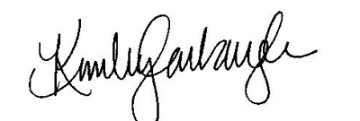

Kimberly Carbaugh
Executive Director

