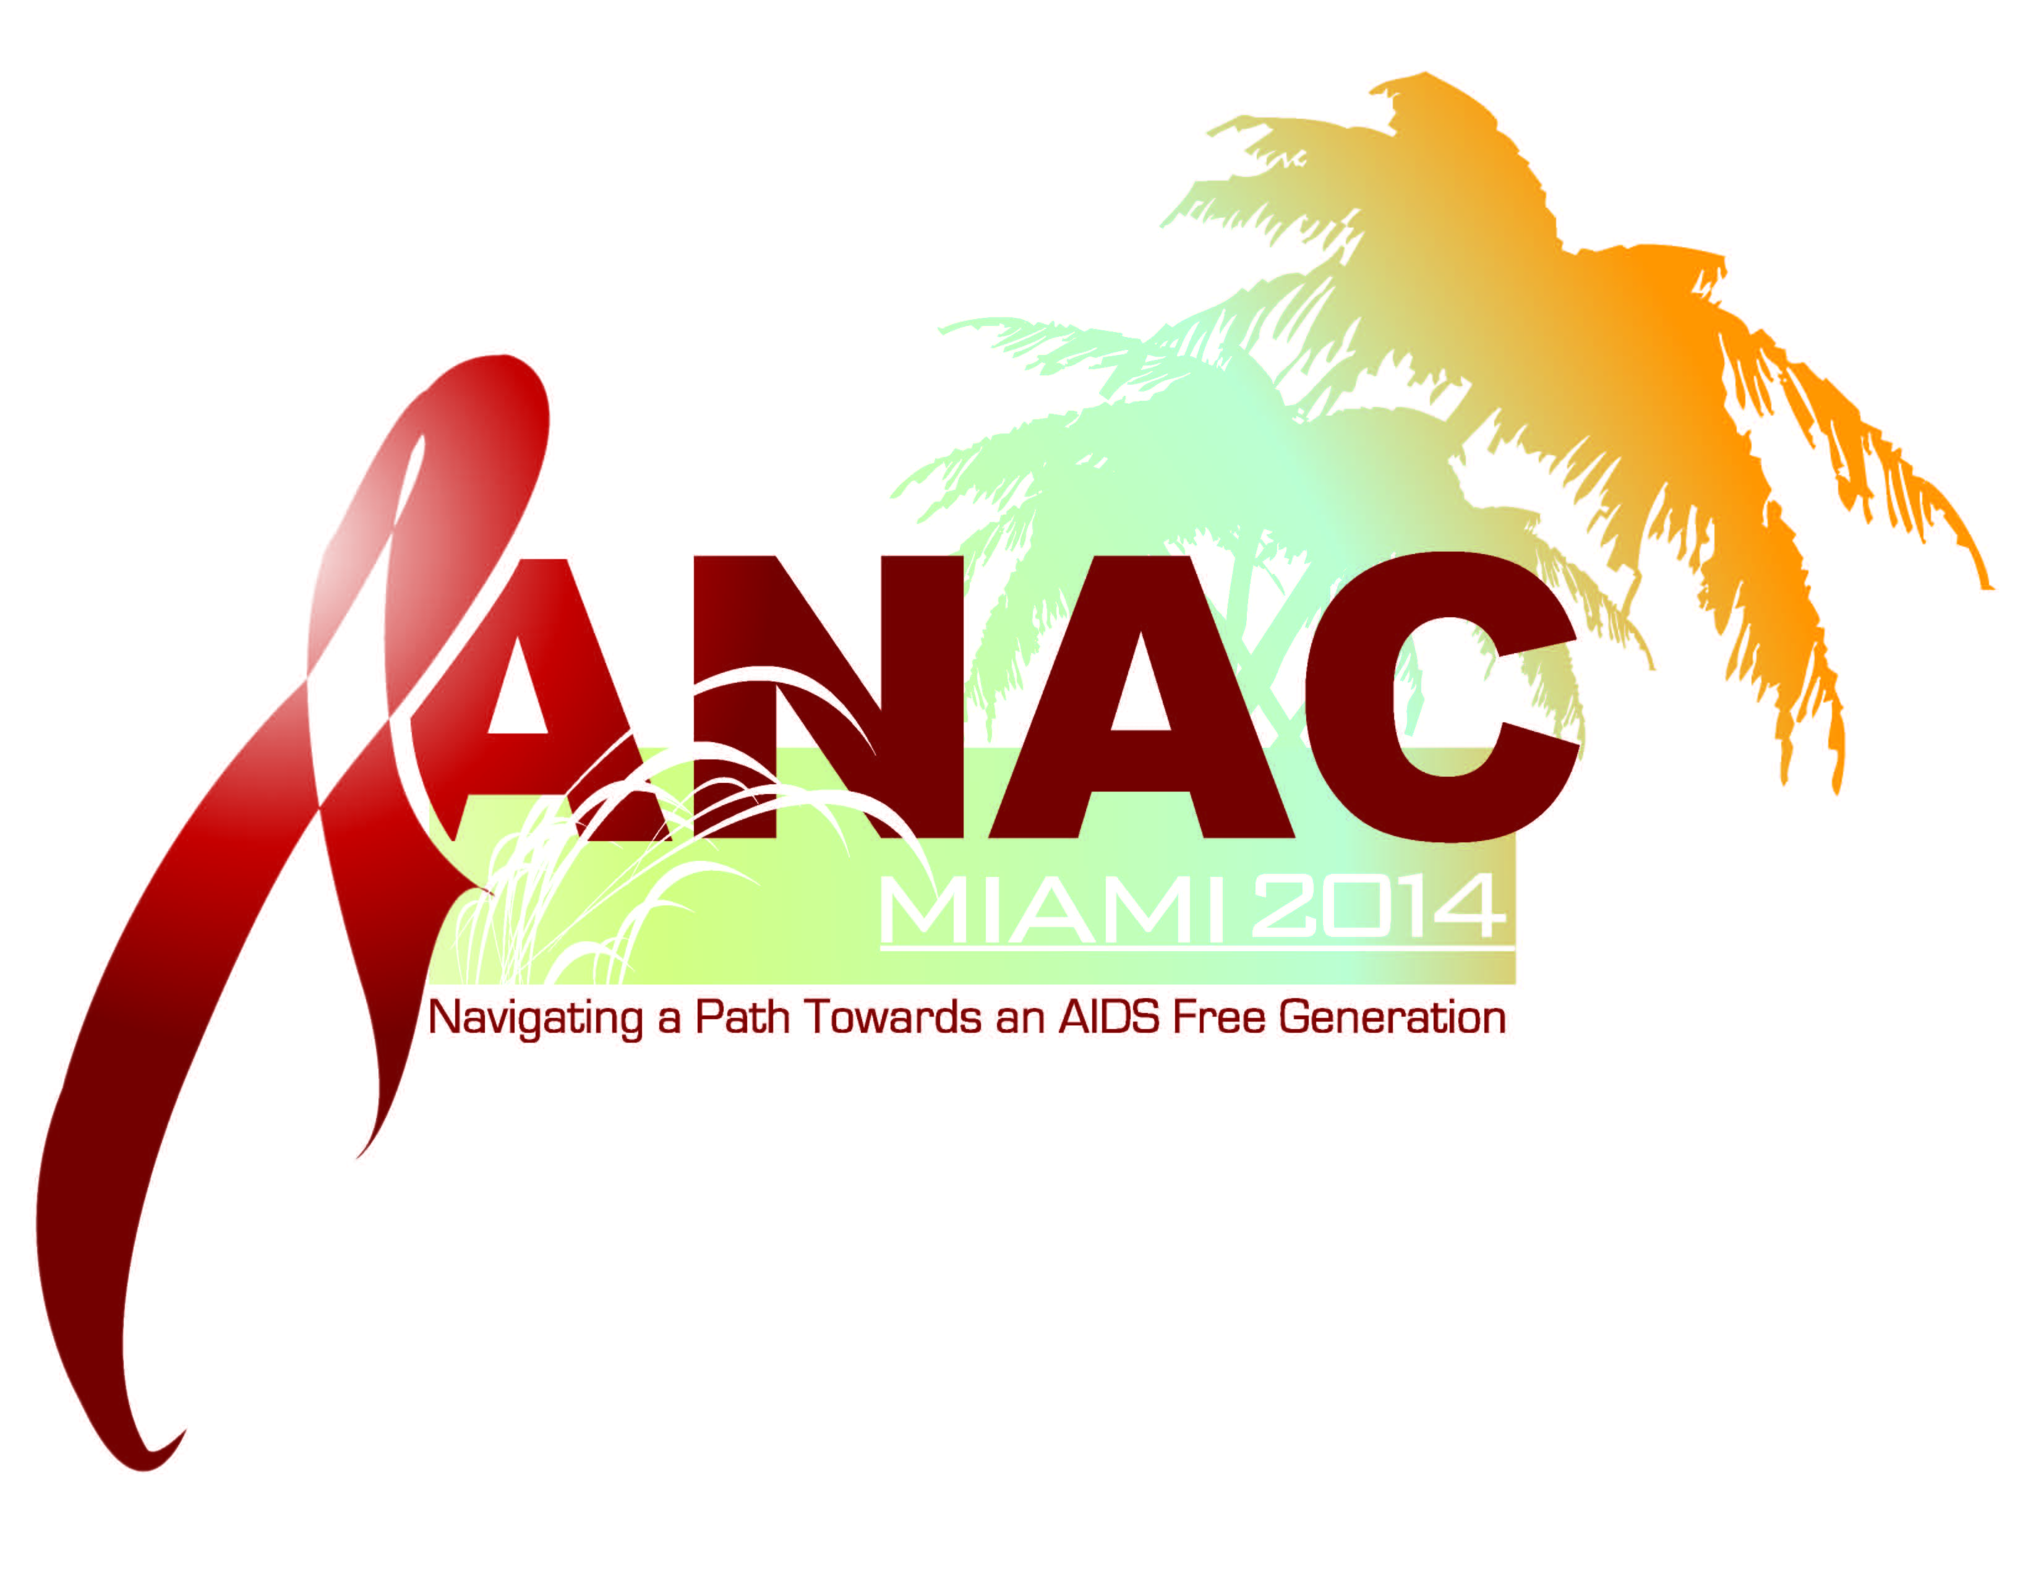
ANAC 2014 Opening Night Gala
White Party Carnival

We are excited to announce that the opening gala reception for ANAC 2014 will be on Thursday, November 6th in Miami. This reception will have a “WHITE PARTY CARNIVAL” theme. This White Party will capture both the festive carnival traditions of tropical neighboring lands and the vibrant feel of the annual Miami circuit White Party. This year’s gala will be historic and full of fun surprises so plan accordingly and be sure to make time to join us for this grand celebration!
Suggested Attire: In keeping with our theme we are asking that all conference attendees wear PURE WHITE outfits to the opening gala. Think relaxed and casual fitting for the chic and festive city of Miami, Latin America, and the Caribbean.
- Get creative with your outfits as there will be a contest for the best PURE WHITE outfits for both men and women.

Activities Planned for the Gala:
- Best Dressed Contest: (Get your WHITE OUTFITS Now before the Summer ends)
- Food & Drink: Come experience the taste of Carnival
- DJ: Spinning International Latin, R&B, and Carnival themed beats
- Dancing: Prepare to move and JUMP-UP Carnival Style
- Entertainment: Special guest TBA
- Plenty of other Surprises!!!

