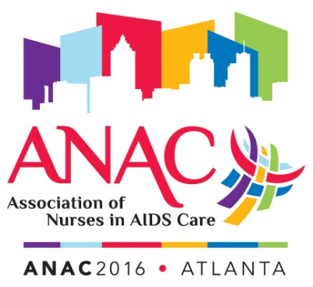

Association of Nurses in AIDS Care
29th Annual Conference
ANAC2016: The Care to Cure Continuum: No One Left Behind
November 10-12, 2016 ∙ The Westin Peachtree Plaza, Atlanta, GA

Conference Registration Form

Please complete all information by typing directly in the grey fields. Telephone registrations will not be accepted. Please note that online registration is available at www.nursesinaidscare.org. You may submit this form via fax if paying by credit card. If paying by check, please print and mail to ANAC at the address listed below.

Full Name:
Address:
City: State: Zip: Country:
Phone: Email Address: Fax:
ANAC ID# (If applicable):

Emergency Contact Information
Name of person to contact in case of an emergency:
Relationship to you:
Phone number of emergency contact:

Conference Fees

Reduced Registration 5-1-2016 Thru 7-15-2016

 | Full Registration | Amount Enclosed
Active/Affiliate Member | $395 | $
Retired Member | $225 | $
Student Member** | $225 | $
Disabled Member | $225 | $
Nonmember | $485 | $
Daily Rate | $175 | $

**Students must be ANAC members to qualify for this rate. Students must submit proof of full-time student status. Nonmember students are
subject to nonmember rates.

Awards Ceremony
Saturday, November 12th, 7:00 – 9:00 pm, $30.00 fee +$30.00

Guest Registration
Includes entry to Gala, Exhibit hall, Awards Ceremony +$200.00
Name of Guest:

Total amount enclosed/to be charged (payment must be in USD) $__________

Method of Payment: Check or money order
Visa
Mastercard
Discover
American Express

Credit Card Authorization

Name on Card: Card Number: Expiration Date: CVV#:

Billing Street Address: Billing Zip Code:

Authorized Signature: ______________________________________________

E-Mail address of person to receive receipt for payment:

Cancellation Policy: Registration cancellations received by the ANAC office on or before October 1, 2016 will receive a full refund, less a $50 administrative fee. All cancellations request must be made in writing. Cancellations received after October 1, 2016 are nonrefundable.

Special Requirements: It is important to us that you enjoy the Conference. If, due to a disability, you have special needs or requirements, please let us know by October 1, 2016 and we will do our best to accommodate you.

Mail/Fax to:
ANAC Conference Registration
3538 Ridgewood Road
Akron, OH 44333
Fax – 330-670-0109

Questions?
Phone: 330-670-0101 or 1-800-260-6780
Fax: 330-670-0109
E-mail: erin@anacnet.org

